**safeT**

**A Mini-Project Report**

**Under**

**Project Workshop**

***Submitted by***

**Nehal Agrawal**

**Krishna Balasubramanian**

**Shon Bangale**

**Niharika Dalal**

***in partial fulfillment for the award of the degree***

***of***

**Bachelor in Technology**

**in**

**Computer Science**

**at**

**Mukesh Patel School of Technology Management & Engineering**

**NMIMS University, Mumbai**

**April, 2015**



**CERTIFICATE**

This is to certify that the project entitled “**safeT**” is the bonafide work carried out by **NiharikaDalal** of B.Tech (Computer Engineering), MPSTME (NMIMS), Mumbai, during the IV semester of the academic year 2015, in partial fulfillment of the requirements for the award of the Degree of Bachelors of Technology as per the norms prescribed by NMIMS. The mini-project work has been assessed and found to be satisfactory.

_______________________ _______________________

Examiner 1 Examiner 2

________________________

Dean

Dr. S.Y. Mhaiskar

**DECLARATION**

We, **Nehal Agrawal (B003), Krishna Balasubramanian (B008), Shon Bangale (B010), NiharikaDalal (B017),** B.Tech (Computer Engineering), IV semester understand that plagiarism is defined as anyone or combination of the following:

1. Un-credited verbatim copying of individual sentences, paragraphs or illustration (such as graphs, diagrams, etc.) from any source, published or unpublished, including the internet.
2. Un-credited improper paraphrasing of pages paragraphs (changing a few words phrases, or rearranging the original sentence order)
3. Credited verbatim copying of a major portion of a paper (or thesis chapter) without clear delineation of who did wrote what. (Source: IEEE, The institute, Dec. 2004)
4. I have made sure that all the ideas, expressions, graphs, diagrams, etc., that are not a result of my work, are properly credited. Long phrases or sentences that had to be used verbatim from published literature have been clearly identified using quotation marks.
5. I affirm that no portion of my work can be considered as plagiarism and I take full responsibility if such a complaint occurs. I understand fully well that the guide of the seminar/ project report may not be in a position to check for the possibility of such incidences of plagiarism in this body of work.

Signature of the Student:

Name:

Roll No

Place:

Date:

Signature of the Student:

Name:

Roll No

Place:

Date:

Signature of the Student:

Name:

Roll No

Place:

Date:

Signature of the Student:

Name:

Roll No

Place:

Date:

**Acknowledgement**

I am thankful to my college and batch-mates for their immense support and help in learning Android Application Programming. I would like to thank our esteemed faculty Ms. Poonam Gupta for her valuable help. I would also like to thank our Head of Department, Mr. Dhirendra Mishra for introducing Implementation of Technology as a subject in our course, to increase our exposure to one of the highly used global technologies; and for his valuable guidance and support in this subject. I am forever indebted to the dean of our college Mr. S.Y. Mhaiskar for providing us with the latest technology and being forever motivational in pursuing our endeavors. I would like to thank my fellow group members for their prodigious help and coordination without which this app would have not been possible.

Lastly, I would like to thank my parents for believing in the distant dream of the app and providing the guidance and motivation to make the idea come to life.

**Table of contents**

|  |  |  |
| --- | --- | --- |
| **Sr. No.** | **Topic** | **Page No.** |
|  | | |
|  | List of Figures | i |
|  | Abbreviation | ii |
|  | Abstract | iii |
| **1** | **Introduction** | **1** |
| **1.1** | **Problem Specification** | **1** |
| **1.2** | **Solution Outline** | **1** |
| **1.3** | **Application/Usage** | **2** |
| **2** | **System Analysis** | **3** |
| **2.1** | **Existing System** | **3** |
| **2.2** | **Software Requirement** | **3** |
| **2.3** | **Hardware Requirement** | **3** |
| **3** | **Design and Methodology** | **4** |
| **3.1** | **Flowchart of App** | **4** |
| **3.2** | **Output (Screenshots of the app)** | **5** |
| **3.3** | **Limitation of App** | **7** |
| **4** | **Conclusion and Future Scope** | **8** |
| **5** | **References** | **9** |

**List of Figures**

|  |  |  |  |
| --- | --- | --- | --- |
| **Chapter No.** | **Title** | | **Page No.** |
|  | | | |
| 3 | Fig 1: Instructions activity | | 5 |
| 3 | Fig 2: ICE Contacts activity | | 6 |
|  | |

i

**Abbreviations**

**Abbreviation Description**

ICE In Case of Emergency

**ii**

**Abstract**

The purpose of us studying android application programming is to cater to the modern industrial needs and criteria to become professional software engineers. This is basically a self-study course which helps us keep no barriers and do selective study to meet the pre-decided course outcomes successfully. This methodology implemented by our college is an open minded approach to education which is changing rapidly to improve the standards of students graduating from imminent universities such as ours. We have referred to a number of books and a plethora of course material related to android application programming. We are indebted to the innumerable anonymous coders and programmers who have shared their knowledge on various Q&A platforms and many video sharing websites. The knowledge we have received from these media have been implemented and we have successfully made our FIRST android application.

Our application is a safety application on the coveted android platform. It is used by a person who may become a prospective victim of various crimes. It helps in letting close friends and family know about the location of the user. The main aim of the application is to work towards a crime-free society and a safe nation.

The purpose of this application is to basically send the location of the user to a few pre-decided contacts on the press of a button. The message is of the Short Messaging Service (SMS) type and thus having a running and operational Short Message Service Pack on the service provider subscription is a primary requirement of the application. The message includes a “Distress Text” which could be something like “I AM IN DANGER!” . This “Distress Text” can be edited by the user to include the language and vocal lingo which could cover a plethora of languages that are available on the phone. The message also includes the location of the user which is sent along with the distress message inside the same text field.

We have implemented the modules of “LocationManager”, “SMSManager”, “DatabaseManager” , “TextView” , “EditText” and the use of “Intent” and “Button”.

**iii**

**Introduction**

**Problem Specification**

The recent incidents of molestation and rape have shaken the country. The level of safety and security of women has deteriorated and has left people concerned, scared and helpless. This app is a step towards reinstating the faith of women in travelling fearlessly anytime, anywhere. The unique features of this app is not only enhance the safety of the woman-user but also keep their friends and family informed of their whereabouts.

**Solution**

Crimes can be tracked and reported by the use of this app. Miscreants and other loose characters can be kept at bay with the help of this app. The app provides an accurate location of the user which also enables the police to reach the spot as soon as possible and increase response time of the police ten-fold.

Aid can be provided to any person in need, at any point of time, by just knowing where he/she is or was at the time of the crime (molestation, rape, abduction, robbery, etc.).

Our application enables the user to share his or her present location to close friends and family.

1

**Application**

- Can be used by both men and women in danger.

- Helps cops to keep a record of dangerous places in city.

- Spreads awareness about unsafe sections of locality.

- The app is targeted towards people who travel often.

- In situations of distress, the user of the app can send an emergency message along with his/her current location.

2

**System Analysis**

**Existing System**

The Google Play Store (link: [www.play.google.com](http://www.play.google.com/)) has a variety

of applications like

* “**M-INDICATOR**”- Send an alert message.
* “**RAKSHA**”- Gives location of the user.

**Software Requirements**

The software required for the current application is

* Minimum android version 2.2 (Froyo).
* Preferred android version 5.0.2(Lollipop)- for material design implementation.

**Hardware Requirements**

A device that supports android operating system.

**3**

**Design and Methodology**

**Flowchart of the App**

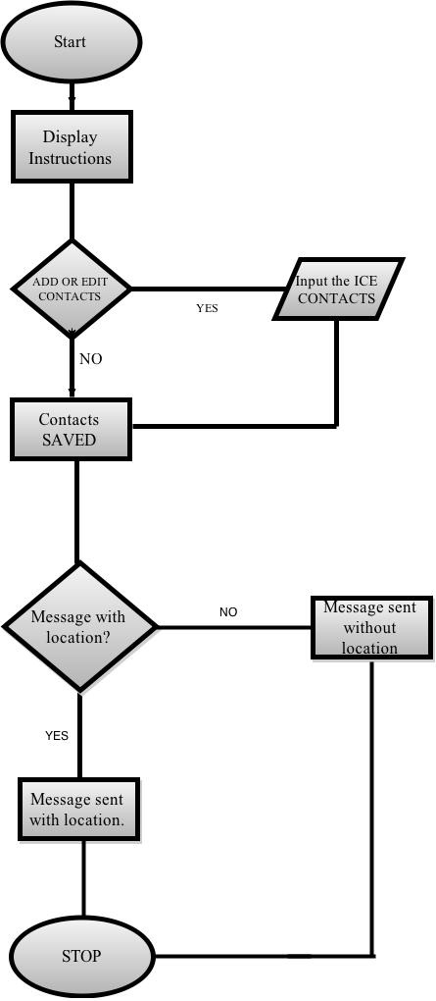

4

**Output**

**(Screenshots of the app)**

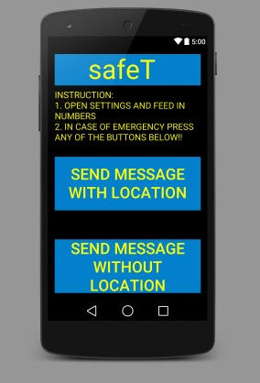

Fig 1: Instructions activity

5

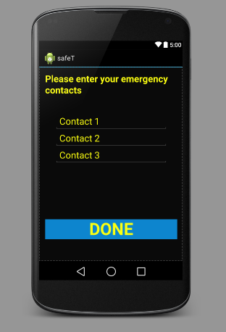

Fig 2: ICE Contacts activity

6

**Limitations of the App**

* Battery Consuming
* Delay in location searching
* Have to open the application to use it (no shortcuts)
* The person should have network coverage

**7**

**Conclusion and Future Scope**

Our Application is towards a better society and crime free world, with special protection to women against heinous felony, and crime prevention at an initial stage. The application can be used by the police to keep track of the areas where such crimes occur frequently and the patrolling schedule can be adjusted accordingly.

In the future, we plan to add an alarm feature which would help in alerting the people in the vicinity about the crime, so as to prevent cases of eve-teasing and other vagabond related troubles.

8

**References**

* youtube.com
* Android 4.0 Oxford Publication
* developer.android.com
* Various other sites like

-Stack Overflow

-Developers.in

-Course era

-Hacker Earth

9